SQL queries with results
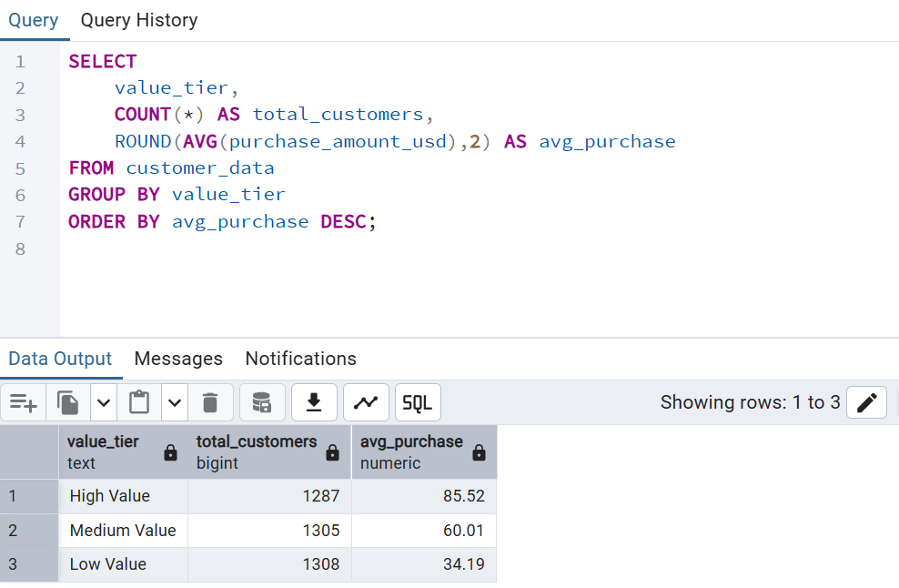

High-Value Customer Segment
Key Finding
- The High-Value segment consists of 1,287 customers.
- These customers have the highest average purchase value of $85.52.
- They contribute the largest share of customer value and revenue generation.
Business Use
- Prioritize retention through VIP loyalty programs.
- Provide personalized recommendations and exclusive benefits.
- Focus on maintaining satisfaction rather than offering frequent discounts.
- Use this segment as the benchmark for identifying future high-value customers.

Medium-Value Customer Segment
Key Finding
- The Medium-Value segment consists of 1,305 customers.
- Their average purchase value is $60.01.
- They represent the largest opportunity for customer value growth.
Business Use
- Implement targeted upselling and cross-selling campaigns.
- Offer product bundles and personalized promotions.
- Encourage more frequent purchases through loyalty incentives.
- Develop strategies to convert these customers into the High-Value segment.

Low-Value Customer Segment
Key Finding
- The Low-Value segment consists of 1,308 customers.
- Their average purchase value is $34.19.
- They contribute the least revenue and show lower engagement levels.
Business Use
- Launch re-engagement and win-back campaigns.
- Use personalized promotions to increase purchase frequency.
- Identify reasons for low spending behavior.
- Improve engagement through targeted communication and offers.

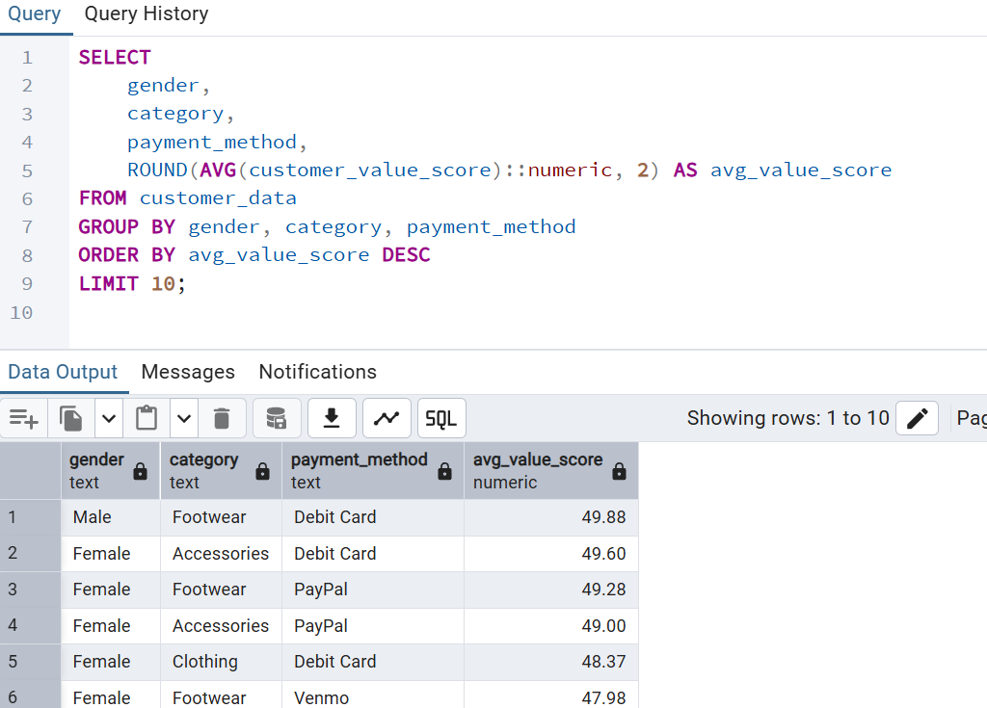
Ideal Customer Profile
The top most segment suggests that the ideal customer is a frequent purchaser within the Footwear category, primarily using Debit Card payments, demonstrating high customer value scores and strong purchasing behavior.

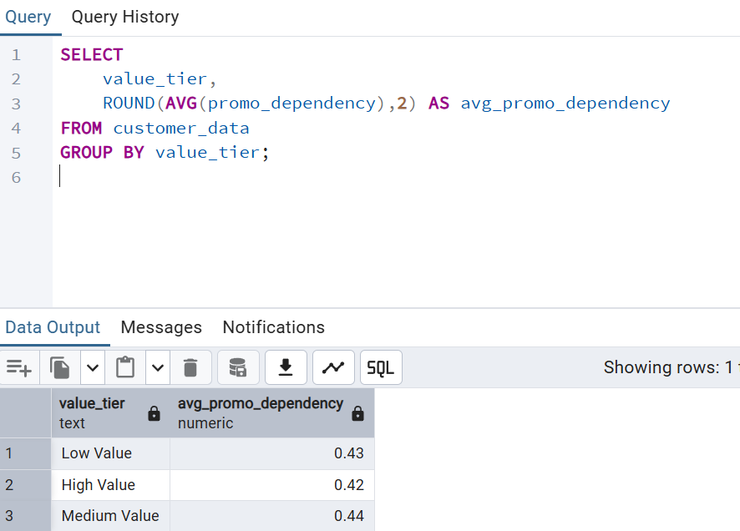

Promo dependent customer segment

Finding

43% customers depend on promotions.

Business Use
Targeted discount optimization.

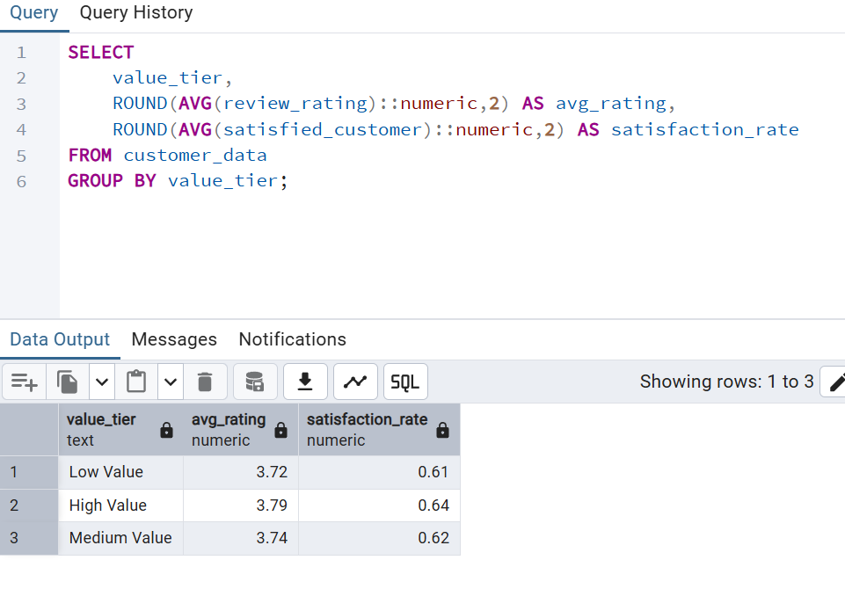
Satisfied Customer Segment
Finding
High-value customers show:
- Rating = 3.79
- Satisfaction Rate = 0.64

Business Use
Protect these customers through loyalty initiatives.

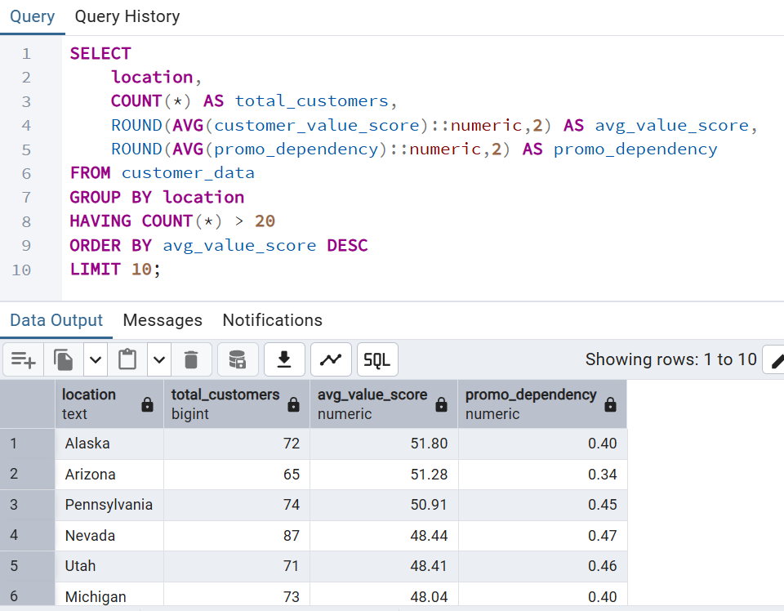
Geographic Opportunities Segment

Finding
Top states:
- Alaska (51.80)
- Arizona (51.28)
- Pennsylvania (50.91)

Business Use
Priority regions for expansion.

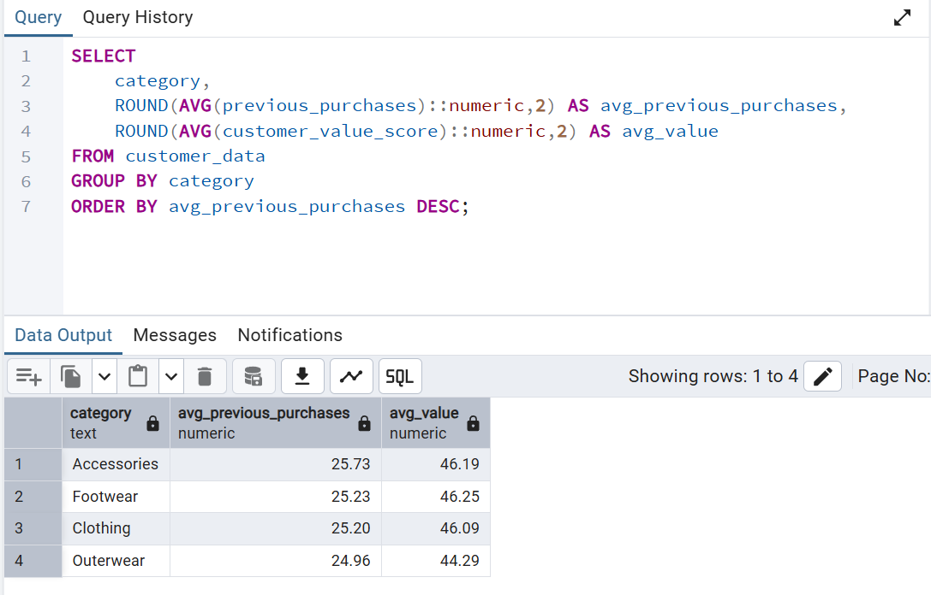
High Performing Category Segment
Findings
Category | Avg Value
Footwear | 46.25
Accessories | 46.19
Clothing | 46.09
Outerwear | 44.29

Business Use
Prioritize Footwear and Accessories in marketing campaigns.

Customer Segmentation Overview
Segment | Customers | Avg Purchase | Key Action
High Value | 1287 | 85.52 | Loyalty Programs
Medium Value | 1305 | 60.01 | Upsell/Cross-sell
Low Value | 1308 | 34.19 | Re-engagement Campaigns

